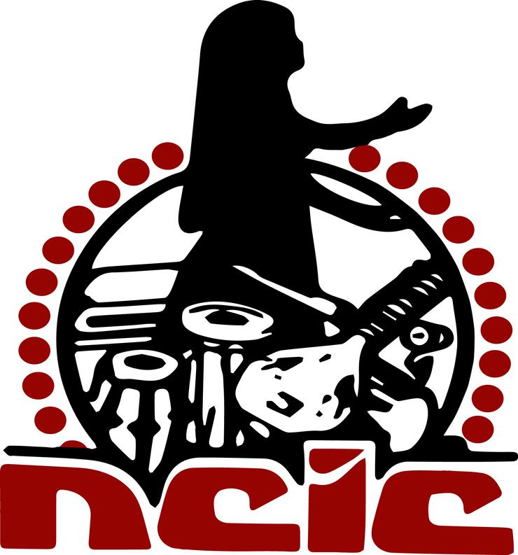

HERITAGE CENTER
FIRST INTERNATIONAL PHAGWA CONFERENCE 2021
Phagwa in the Global Village:
Traditions, Innovations and Future Developments
FIPC2021

NCIC Nagar, 28-38 Narsaloo Ramaya Marg, Endeavour, Chaguanas 502128, Trinidad, W.I.

Tel/Fax: (868) 671-6242 / 789-9101 Email: phagwafipc2021@gmail.com; pgoopta@hotmail.com;

Website: http://www.ncictt.com

25 JULY 2020

CALL FOR PAPERS
Theme: Phagwa in the Global Village:
Traditions, Innovations and Future Developments
Date: Saturday 30 January 2021
Time: 8.00 am—6.00 pm.
Venue: National Council of Indian Culture, Trinidad
Platform: Virtual Conference (Zoom)

The National Council of Indian Culture (Trinidad and Tobago) Heritage Center invites you to submit abstract proposals for a virtual international academic conference entitled “Phagwa in the Global Village.”

BACKGROUND

The Phagwa festival (Holi) has been an integral part of the lives of Diasporic Indians the world over. .It originated in India and spread throughout the world where Indians settled either as indentured immigrants or free men. While it has gained in popularity over the years, few efforts have been made to study this festival from an academic standpoint
.
OBJECTIVES
The objectives of the conference are:
- To present and encourage opportunities for diasporic researchers and scholars to engage in global dialogue on the Phagwa Festival.
- To advance the achievement of a progressive Indian diasporic Phagwa world community through collaboration and dialogue on various issues through research, the exchange of ideas, concerns, solutions, problems, and professional relationships.
- To encourage inquiry by diasporic scholars, researchers and others on the Phagwa Festival .
- To publish high quality research papers on the Phagwa Festival.

TOPICS
The topics derived from the conference theme and areas of discussions listed below are not exhaustive. Additional topics may be added as long as they contribute to the body of knowledge of the Phagwa Festival and relate to the theme of the conference.

- The origins of Phagwa.
- Historical experiences that have shaped the Phagwa Festival over the years.
- Cultural and social impact of the Phagwa festival.
- The Phagwa Festival during and after Indentureship.
- Phagwa celebrations in India.
- Phagwa in the context of the Caribbean, North America and Europe.
- The politicization of Phagwa .
- The re-creation of Phagwa among the Indian diaspora.
- Phagwa as a Community Festival.
- Developing trends in the Phagwa Festival in India and the Indian Diaspora.
- Equality and Freedom in the Phagwa Festival.
- Youth in the Phagwa Festival.
- Portrayal of Phagwa in the literature, film, art, media and other fora.
- Phagwa as an all-inclusive festival.
- Gender issues in the Phagwa Festival
- The songs of the Phagwa Festival (Chowtaal, Ulaara, filmi, Pichakaree and others).
- The Pichakaree Competition (The Hindu Prachar Kendra, Trinidad).
- The (early) use of stimulants (e.g. Bhang, alcohol, etc.) in the Phagwa Festival.
- The romanticization of the Phagwa Festival in Indian movies.
- Children’s Phagwa Festival.
- Similarities between the Phagwa Festival and other festivals.
- The Phagwa Festival in the context of the environment and sustainability issues.
- The Ramayana and the Phagwa Festival.

- The conference will be in English.
- Participants will be allowed 15 minutes (maximum) on the day of the conference to present a summary of their papers. PowerPoint presentations for this purpose will be welcomed.
- Panels will comprise up to four presentations.
- Abstracts (250 words) and a short Bio (2 paragraphs) must be submitted by 30 September, 2020.

IMPORTANT DATES
- Submission of Paper Abstracts 30 September 2020
- Notification of acceptance of paper 05 October 2020
- Full paper submission 20 December 2020

Abstracts and full papers should be submitted in Ms Word format, single spaced, using Times New Roman, 12 point. Full papers should be submitted in MLA Format.

Submission of Abstracts

Submission of abstracts and papers should be sent via email to:

The Chairman,
NCIC First International Phagwa Conference

- phagwafipc2021@gmail.com;
and copied to
- pgoopta@hotmail.com;

Tel: 1-868-470-0133

CONFERENCE DATES

Saturday 30 January 2021. 8.00 am –6.00 pm
Platform: Zoom

There is no registration fee for paper presenters for the conference.

NCIC

The National Council for Indian Culture (NCIC)] was established in 1964. It is the main Indian diasporic cultural organization in Trinidad. It has hosted several local and international conferences, cultural missions and artistes from India and elsewhere. It organizes several annual projects to commemorate important dates on the Indian Diaspora cultural calendar, with Divali Nagar being its flagship event.

CONFERENCE COMMITTEE :
Trinidad : Dr.Primnath Gooptar, (Chair), Deoroop Teemal, Dr. Jerome Teelucksingh, Professor Brinsley Samaroo, Surujdeo Mangaroo, Pandita Geeta Ramsingh, Dr.Deokinanan Sharma, Satyanan Gosine (National Phagwa Council, SDMS (to be confirmed), Pt. Jaidath Maharaj (Swaha), Dr. Sherry Ann Singh, Dr.Radica Mahase, Amrica Seepersad, Shawn Ramjit and Dr.V.Vijay Maharaj..

International : Dr.Tara Singh (New York), Pt. Ravi Sharma (Canada), Gangaram Panday (Suriname), A. Anroedh (Suriname), Dr.Vindhya Persaud (Guyana), Preetema,J. Pahaladsing (Suriname), Satyendra Peertham (Mauritius), Sarita Boodhoo (Mauritius ), Prof. Molly Kaushal (India), Dr. Sunil Kumar (Fiji/New Zealand), Prof. Mohan Gautam (Netherlands), Dr. Anjali Singh (India),Ujjwal Rabidas (India), Pt Teeluck Seerattan Maharaj (New York), Annapurna Pandey (USA), Kalpana Hiralal (South Africa), Rishi Gupta (India), Bisnauth Persaud (London), Kathleen Boodhai (London), Sarita Nandmehar (India).

Sincerely,

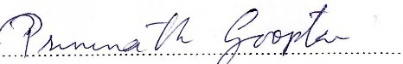
Conference Chair

